If you would rather buy than build your boxes, below are some currently (spring 2017)available:
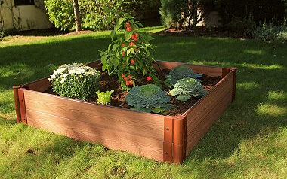

$71.98 at Sam’s Club Item #: 387986
Frame It All–Simple Modular Gardens are the gardens that grow with you. 1” x 4ft. x 4ft. x 11in. Composite Raised Garden Bed Kit can be used as a stand-alone raised garden bed or as a module to extend any Frame It All Raised Garden Bed System. If your love of gardening runs deep, you’ll appreciate the extra soil depth the 4' x 4' x 11" kit provides. Almost any type of crop will thrive in an 11" bed–even root vegetables. Patented anchor joint allows installation on hard surfaces (such as rooftops, patios or decks) and traditional soft surface landscapes. With 16 square feet of available planting area, you’ll find many uses for this versatile kit.
- Eco-friendly timbers are made from recycled plastic and natural fibers
- No toxic chemicals
- Frame It All’s modular system allows endless design options
- Add on or reconfigure your raised garden bed at any time using existing or additional One Inch Series Frame It All components and accessories
- Low maintenance—timbers will not rot, warp, splinter or fade
- Composite boards are made from 38% post-consumer recycled plastic and 62% sustainable hardwood fibers
- One Inch Series composite kits are made from 1in. thick, rounded profile boards
https://www.samsclub.com/sams/1in-4x4ft-2-level-raised-garden/prod20323053.ip?athcpid=prod20323053&athena=true&athpgid=pdp&athmtid=VaV&athznid=sams_ip_VaV&parentpid=prod20323017&xid=pdp:carousel:people-who-viewed-this-item-also-viewed:2

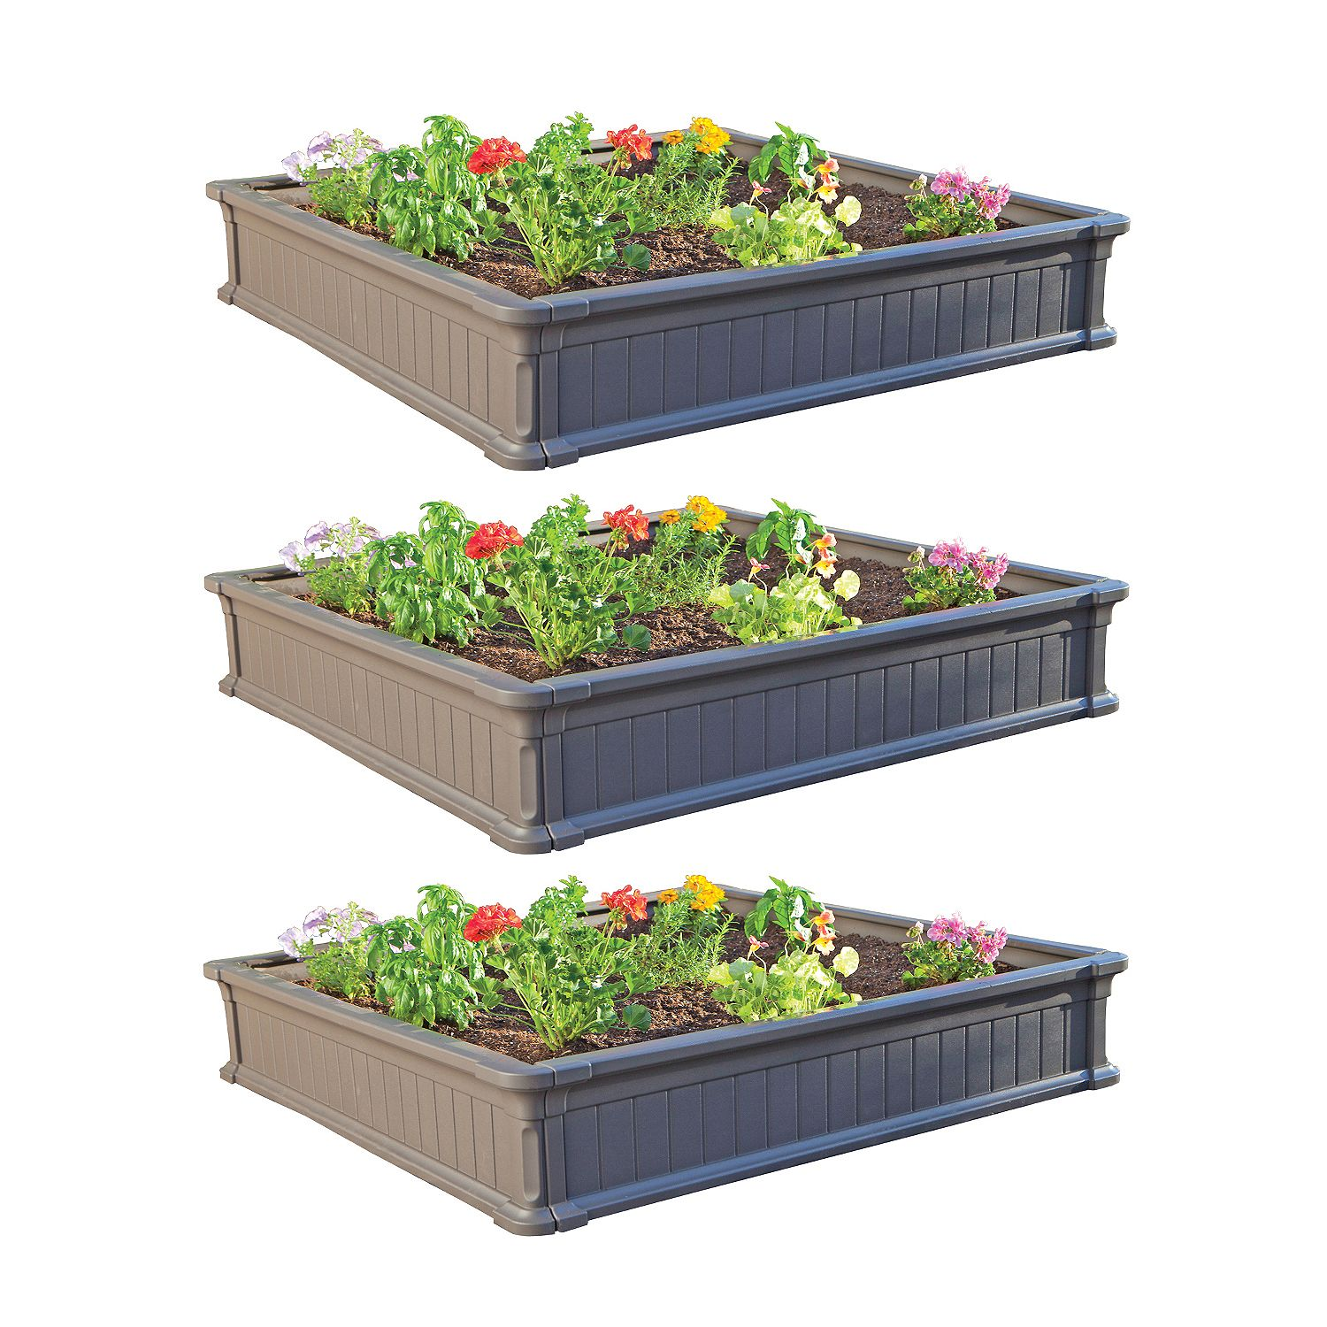

$136.94 at Sam’s Club (for three) Item #: 102251

Lifetime 4' Raised Garden Bed (3 pk.)
- 4 'x 4' Lifetime Raised Garden Bed
- 9" high stackable walls
- Easy interlocking assembl
- 4 pieces, making one 4' x 4' box, brown
- 5-year limited warranty
https://www.samsclub.com/sams/lifetime-4-raised-garden-bed-3-pk/prod5710428.ip?athcpid=prod5710428&athena=true&athpgid=pdp&athmtid=VaV&athznid=sams_ip_VaV&parentpid=prod8450163&xid=pdp:carousel:people-who-viewed-this-item-also-viewed:4

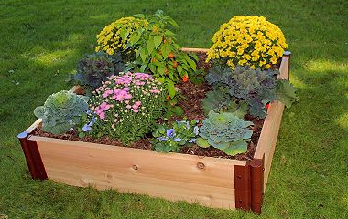

$83.98 at Sam’s Club Item #: 387424

Frame It All Raised Garden Cedar 1" 4' x 4", 2-Level
- Raised garden bed kit
- Simple modular gardens that grow with you
- Eco-friendly timbers are made from recycled plastic and natural fibers
- Low maintenance
- Timbers will not rot, warp, splinter or fade

https://www.samsclub.com/sams/cedar-4x4ft-2-level-raised-garden/prod20323019.ip

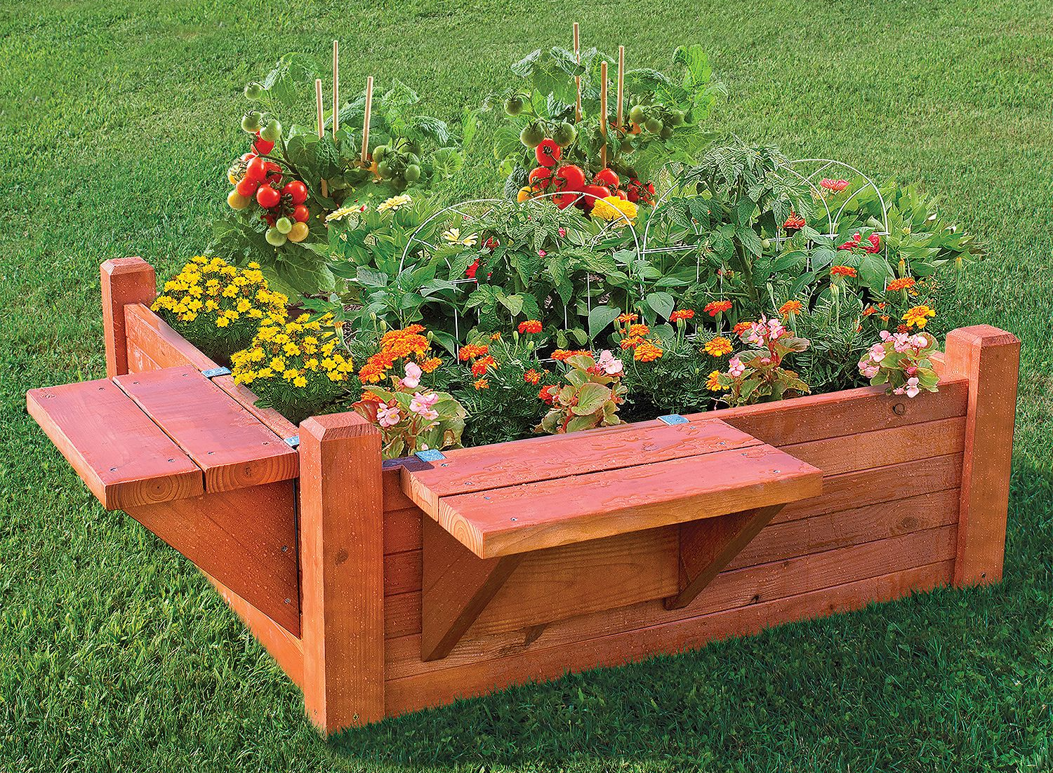

$78.98 at Sam’s Club Item #: 240452

4' x 4' Garden Bed with Seat/Shelf

- 4ft x 4ft x 16 “ deep
- For deep-rooted vegetables
- Moveable seating or handy shelves

https://www.samsclub.com/sams/4x4-gardn-bed-dsv-w-seat-or-shlf-2016/prod20130160.ip?xid=plp:product:1:11

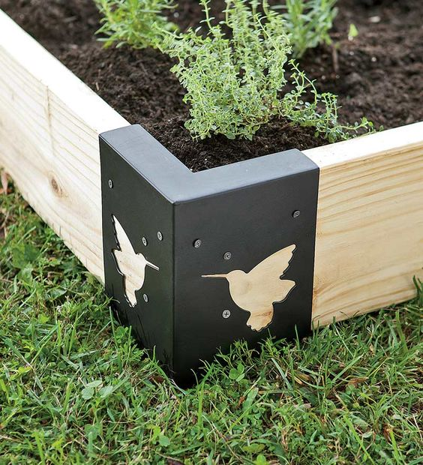

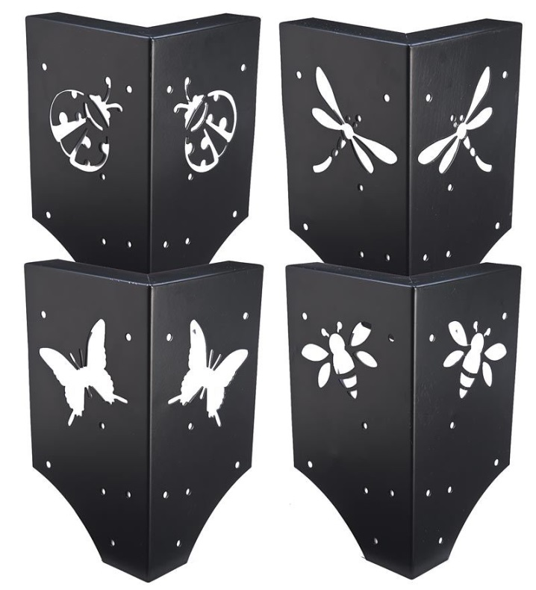
These brackets make assembling your boxes from 2x lumber super easy!
Plow & Hearth Call 800-494-7544
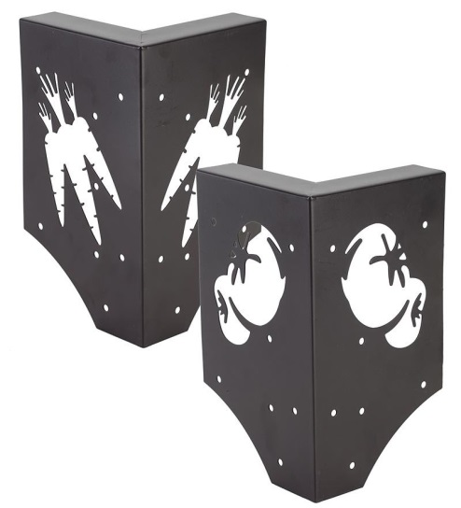
Lumber $30 + $25 for bracket = $55 per bed, 4ft x 4 ft x 12” deep with 2” thick lumber

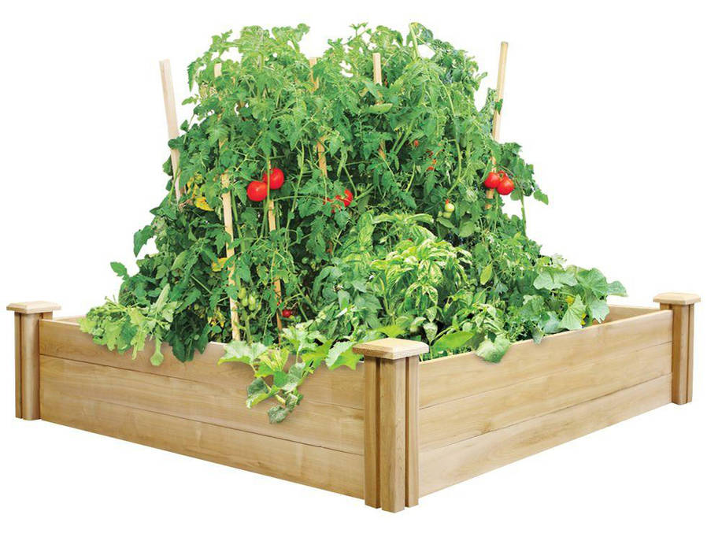

$76.47 from WalMart online, store delivery
Greenes Fence 4' x 4' x 10.5" Cedar Raised Garden Bed

https://www.walmart.com/ip/Greenes-Fence-4-x-4-x-10.5-Cedar-Raised-Garden-Bed/48569342?action=product_interest&action_type=title&beacon_version=1.0.2&bucket_id=irsbucketdefault&client_guid=e6099f95-22e3-4cc3-8a44-3f2a5a162fb7&config_#about

